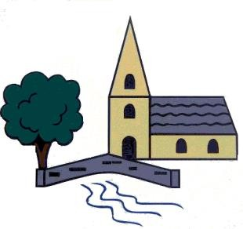
Sculpture and 3D: Interactive Installation
Autumn 1
- What is installation art?
- Can you talk about an installation artist?
- How is installation art different to sculpture?
- What is performance art?

Sticky Knowledge – Art & Design Class – Maples
Year 5

Drawing: I need space
Spring 1
- What is retro-futurism?
- What choices do artists have when they are creating a piece of art?
- Can you talk about the work of Tiers Albers?
- What is a collagraph?

Painting and mixed media: Portraits
Summer 1
- What is a portrait?
- What term is used when someone makes a portrait of themselves? Can you talk about any famous self-portraits?
- What do ‘mixed-media’ and ‘multi-media’ mean?

