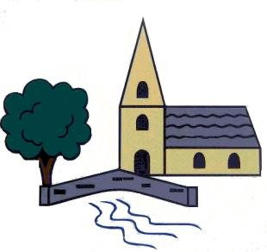

Sculpture and 3D: Interactive Installation

Autumn 1

* What is installation art?
* Can you talk about an installation artist?
* How is installation art different to sculpture?
* What is performance art?

Sticky Knowledge – Art & Design Class – Maples

Year 5

Drawing: I need space

Spring 1

* What is retro-futurism?
* What choices do artists have when they are creating a piece of art?
* Can you talk about the work of Tiers Albers?
* What is a collagraph?

Painting and mixed media: Portraits

Summer 1

* What is a portrait?
* What term is used when someone makes a portrait of themselves? Can you talk about any famous self-portraits?
* What do ‘mixed-media’ and ‘multi-media’ mean?