

Busy Bees Out of School Club
Halifax Road, Ripponden, Sowerby Bridge, HX6 4AH Tel : 01422 823362

email: office@ripponden.calderdale.sch.uk
www.ripponden.calderdale.sch.uk

17th September 2025

Dear parents/carers,

We will be open all of October half term, plus the training day after. Here is the October half term programme:

Monday 27th Breakfast served between 8-9am | Tuesday 28th  Breakfast served between 8-9am | Wednesday 29th  Breakfast served between 8-9am | Thursday 30th  Breakfast served between 8-9am | Friday 31st  Breakfast served between 8-9am
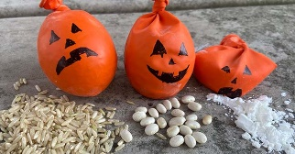  Hallowe’en Stress Balls |   Cotton Wool Ghosts |   Bubbling Witch Cauldron Pictures |   Flying bat Craft | Mummy Jar Lanterns  Can also come in fancy dress!  
Lunch 12-1pm  Please bring a packed lunch | Lunch 12-1pm  Please bring a packed lunch | Lunch 12-1pm  Please bring a packed lunch | Lunch 12-1pm  Please bring a packed lunch | Lunch 12-1pm  Please bring a packed lunch
Spooky Masks   | Monster Muffins   | Monster Moon Sand  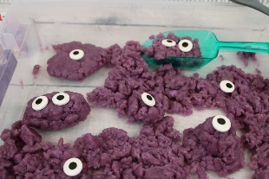 |   Graveyard Pudding Cups |   Hallowe’en Party and Games
Snack between 3.30-4.30pm | Snack between 3.30-4.30pm | Snack between 3.30-4.30pm | Snack between 3.30-4.30pm | Snack between 3.30-4.30pm

Holiday club is open to all children, whether they usually attend Busy Bees or not and can be booked as a full or half day session (half day being 8am-1pm or 1pm-6pm). We offer a sibling discount.

Fees for Holiday Club at Busy Bees:
 | Fees
Half Day (8am-1pm or 1-pm-6pm) 1st child | £13.50
Half Day (8am-1pm or 1-pm-6pm) Sibling | £12.50
Full day (8am-6pm)  1st child | £27.00
Full day (8am-6pm)  Sibling | £25.00

This includes breakfast, morning and afternoon snacks and all activities. Children are required to bring a packed lunch.

Please book places for the club on the app as soon as possible. For parents of children who do not attend Ripponden School ONLY, please email office@ripponden.calderdale.sch.uk Please note, sessions booked will be required to be paid for, even in the event of non-arrival, unless under exceptional circumstances, which will be determined by the headteacher.

Many thanks for your continued support,

The Busy Bees Team.

