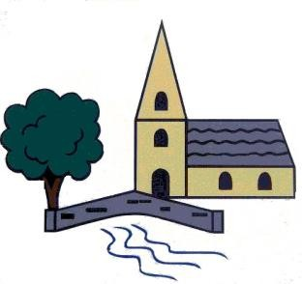

Sticky Knowledge- History Class – Maples

Year 5

What did the Vikings do for Britain?

Autumn 2

How terrible were The Tudors?

Summer 1

* Where and when did Vikings invade?
* Why did the Vikings come to Britain?
* What does evidence teach us about Vikings?
* How did the Vikings change England?
* Who was the first Tudor King and when did he become king?
* Why is Henry VIII so famous in British History?
* How were Tudor buildings, including Shibden Hall, constructed?
* Why is Queen Elizabeth I so famous in British History?

The Maya Civilisation

Summer 2

* Where in the modern world and when did the Maya civilisation live?
* What rituals and sacrifices did the Maya people make to their gods? (Why?)
* What significant areas were the Maya advanced in?