SUBMITTING WORK TO GOOGLE CLASSROOM

Because Google Classroom can be accessed from any Internet-enabled device, there are so many different ways of connecting. Apparently you can even connect to Google Classroom from a PlayStation (children, please don’t get any ideas)!

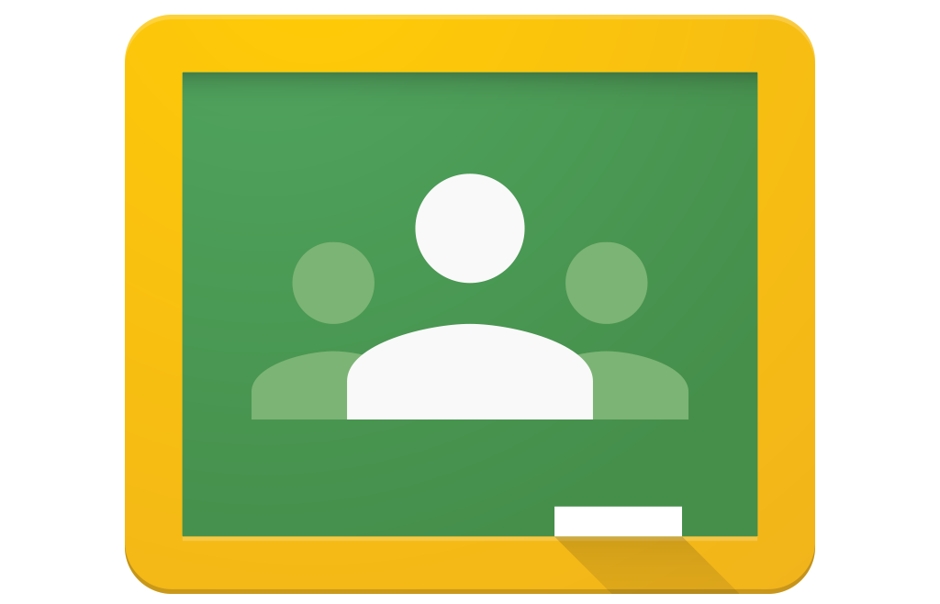
To make matters even more complicated, there are also so many different ways for teachers to create work! Although we recognise it is stressful and that there is a lot to learn, we see this period of home learning as a unique opportunity to teach your children (and you!) to become more digitally literate.

Below, you will find video guides to uploading work to Google Classroom for a range of different devices, depending on the type of activity attached by your teacher(s). Please bear in mind that, depending on the make, model, specification and age of your device, what you see on your device may differ slightly to what you see in the videos.

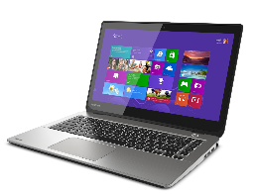
Submitting work from a laptop or computer

- Uploading photos: http://tiny.cc/7z68tz
- Using Google Docs: http://tiny.cc/wz68tz
- Completing work on a PDF: http://tiny.cc/d378tz

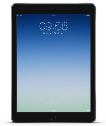
Submitting work from an iPad

- Uploading photos: http://tiny.cc/2478tz
- Using Google Docs: http://tiny.cc/4478tz
- Completing work on a PDF: http://tiny.cc/6478tz

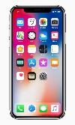
Submitting work from an iPhone

- Uploading photos: http://tiny.cc/v378tz
- Using Google Docs: http://tiny.cc/x378tz
- Completing work on a PDF: http://tiny.cc/1478tz

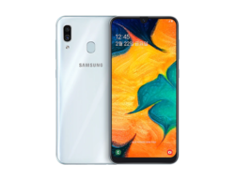
Submitting work from an Android smartphone

- Uploading photos: http://tiny.cc/bc78tz
- Using Google Docs: http://tiny.cc/7c78tz
- Completing work on a PDF: http://tiny.cc/6c78tz

