
Ripponden J&I School
Accessibility Policy
October 2025 – to be reviewed October 2028

At Ripponden J&I School our values reflect our commitment to a school where there are high expectations of everyone. Children are provided with high quality learning opportunities so that each child attains and achieves all that they are able to. Everyone in our school is important and included. We promote an ethos of care and trust where every member of our school community feels that they truly belong and are valued. We work hard to ensure there are no invisible children here, recognising everyone’s uniqueness and success. We recognise learning in all its forms and are committed to nurturing lifelong learners. We are a safe school, committed to improving children's confidence and self-esteem. We know that safe and happy children achieve.

Ripponden J&I School demonstrates a strong commitment to ensuring pupils with disabilities can fully participate in the curriculum. The school’s inclusive ethos, reflected in its “Branch Out” values of kindness, respect, enthusiasm, resilience, and making good choices, underpins all aspects of learning and social development. Current good practice includes a thoughtfully arranged physical environment with step-free access, wide doorways, and flexible classroom layouts that accommodate mobility aids and provide height-adjustable desks where needed. The school uses a range of accessible learning materials, including printed, digital, and large print formats, alongside assistive technologies such as tablets with accessibility features. Visual supports such as symbols and diagrams are routinely used to reinforce instructions. Teaching practises promote clear, step-by-step instructions supported by visual and written prompts, and predictable routines are established through visual timetables tailored for children with autism or other specific needs. The school fosters inclusive participation in all areas including PE, music, art, and extracurricular clubs, supported by peer buddy systems that encourage social and academic inclusion. Staff receive ongoing training in disability awareness and autism-friendly practises, ensuring that communication is clear and inclusive. The school’s proactive anti-bullying culture, sensory rooms, calming areas, and accessible playground facilities further support the wellbeing and engagement of pupils with disabilities. These practises align with the school’s improvement priority to develop SEND provision and respond positively to OFSTED’s recognition of the school as an inclusive environment with high expectations for all pupils.

This Accessibility Plan is drawn up in compliance with current legislation and requirements as specified in Schedule 10, relating to Disability, of the Equality Act 2010. School Governors are accountable for ensuring the implementation, review and reporting of progress of the Accessibility Plan over a prescribed period.

The Equality Act 2010 replaced all existing equality legislation, including the Disability Discrimination Act. The effect of the law is the same as in the past, meaning that “schools cannot unlawfully discriminate against pupils because of sex, race, disability, religion or belief and sexual orientation”.

According to the Equality Act 2010 a person has a disability if:

- He or she has a physical or mental impairment, and

- The impairment has a substantial and long-term adverse effect on his or her ability to carry out normal day-to-day activities.

The Accessibility Plan is structured to complement and support the school’s Equality Objectives, and will similarly be published on the school website. We understand that the Local Authority will monitor the school’s activity under the Equality Act 2010 (and in particular Schedule 10 regarding Accessibility) and will advise upon the compliance with that duty.

Objectives
Ripponden J&I School is committed to providing an environment that enables full curriculum access that values and includes all pupils, staff, parents, and visitors regardless of their education, physical, sensory, social, spiritual, emotional and cultural needs. We are committed to taking positive action in the spirit of the Equality Act 2010 with regard to disability and to developing a culture of inclusion, support and awareness within the school.

We recognise and value parent’s knowledge of their child’s disability and its effect on their ability to carry out everyday activities and respects the parent’s and child’s right to confidentiality.

Ripponden J&I School’s Accessibility Plan shows how access is to be improved for disabled pupils, staff and visitors to the school within a given timeframe and anticipating the need to make reasonable adjustments to accommodate their needs where practicable.

The Accessibility Plan contains relevant and timely actions to: -

- Increase access to the curriculum for pupils with a physical disability and/or sensory impairments, expanding the curriculum as necessary to ensure that pupils with a disability are as equally prepared for life as the able-bodied pupils; (If a school fails to do this they are in breach of their duties under the Equalities Act 2010); this covers teaching and learning and the wider curriculum of the school such as participation in after-school clubs, leisure and cultural activities or schools visits – it also covers the provision of specialist or auxiliary aids and equipment, which may assist these pupils in accessing the curriculum within a reasonable timeframe;

- Improve and maintain access to the physical environment of the school, adding specialist facilities as necessary – this covers improvements to the physical environment of the school and physical aids to access education within a reasonable timeframe.

- Improve the delivery of written information to pupils, staff, parents and visitors with disabilities; examples might include hand-outs, timetables, textbooks and information about the school and school events; the information should be made available in various preferred formats within a reasonable timeframe.

The Ripponden J&I School Accessibility Plan relates to the key aspects of physical environment, curriculum and written information.

Whole school training will recognise the need to continue raising awareness for staff and governors on equality issues with reference to the Equality Act 2010.

This Accessibility Plan should be read in conjunction with the following school policies, strategies and documents:

- Behaviour Management Policy
- Curriculum Policies
- Emergency Plan
- Health & Safety Policy
- School Development Plan
- Special Educational Needs Policy

Equality Impact Assessments will be undertaken as and when school policies are reviewed. The terms of reference for all governors’ committees will include the need to consider Equality and Diversity issues as required by the Equality Act.
The Accessibility Plan will be published on the school website.

The Accessibility Plan will be monitored through the Full Governing Body meetings.

The Accessibility Plan may be monitored by Ofsted during inspection processes in relation to Schedule 10 of the Equality Act 2010.

It is a requirement that the school’s accessibility plan is resourced, implemented, reviewed and revised as necessary and reported on annually. Attached is a set of action plans showing how the school will address the priorities identified in the plan.

The priorities for the Accessibility Plan for our school were identified by:

The Governing Body
- Head Teacher
- School Business Manager
- Caretaker


Plan of the school:

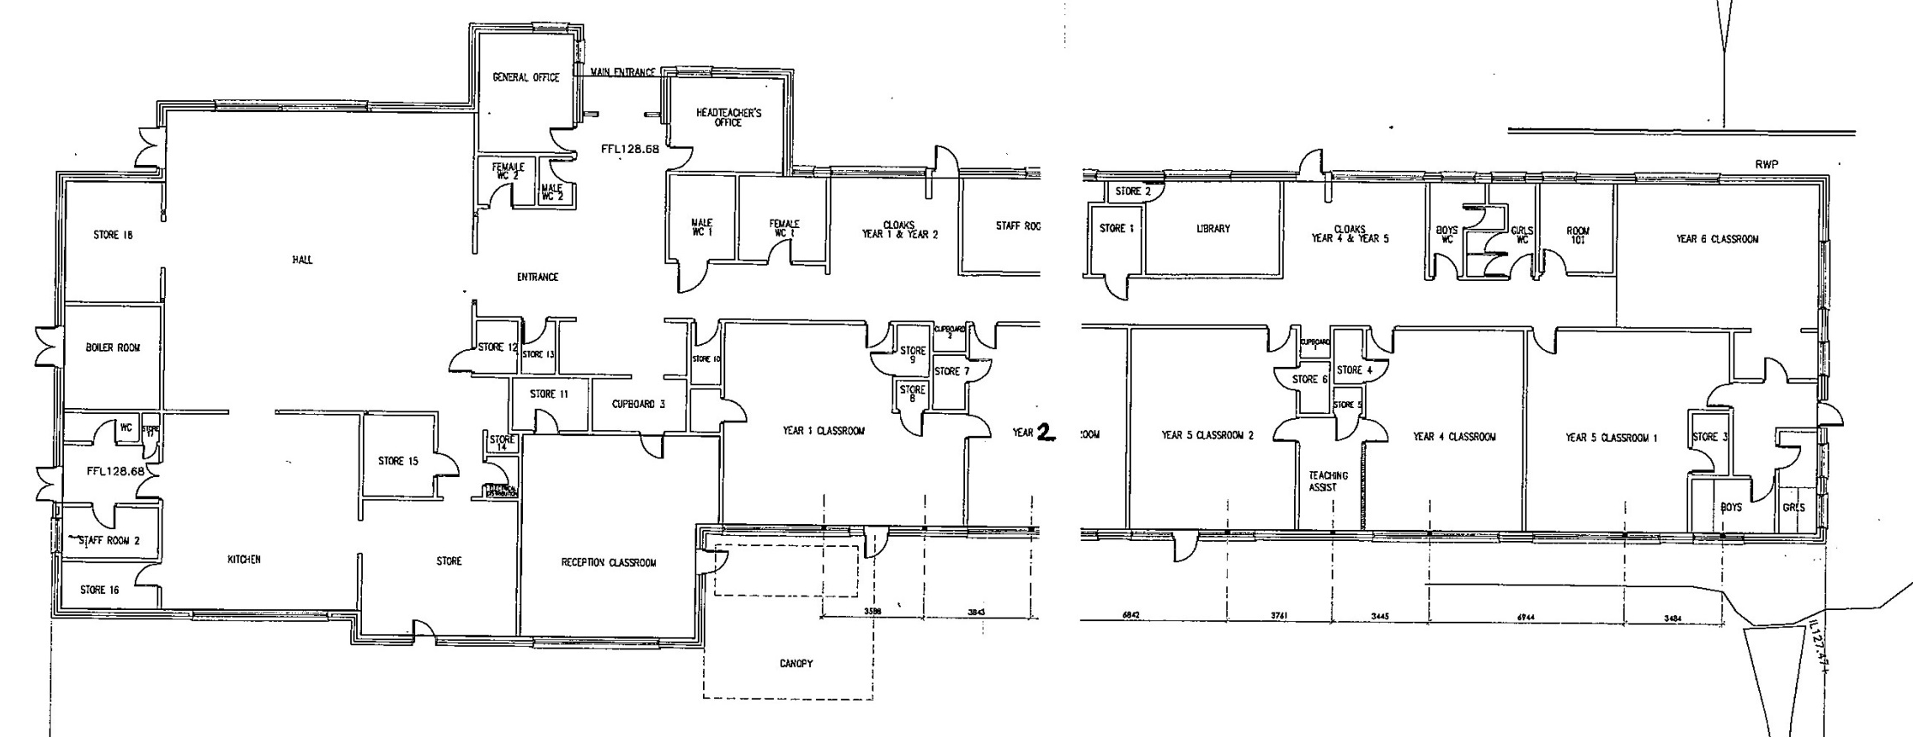
Teacher Resource Room
The Den
Kitchen
Hall
Staff toilets
Main entrance
Admin Office
Headteacher’s Office
The Woodland Room
Great Oaks (Y2) Classroom
Saplings (Y1) Classroom
Toilets
Learning Zone 1
Staff room
Chestnuts (Y3) Classroom

Prep room
The Dell
Toilets
Learning Zone 2
Willows (Y4)
Classroom

Busy Bees Classroom
Redwoods (Y6) Classroom

Maples (Y5) Classroom

Objective | Actions to be taken | Success Criteria | Person Responsible | Timeframe
1. Increase access to the curriculum for pupils with physical disabilities and/or sensory impairments, ensuring equal preparation for life alongside able-bodied pupils | - Review and adapt curriculum planning to identify and remove barriers to participation for disabled pupils in all subjects, including after-school clubs, trips, and cultural activities  - Provide specialist or auxiliary aids and equipment as needed (e.g., hearing aids, adapted PE equipment)  - Train staff on differentiated teaching strategies specific to physical and sensory disabilities  - Develop individual learning support plans with precise, small-step targets for pupils with SEND  - Monitor and evaluate participation rates of disabled pupils in all curricular and extracurricular activities | - Curriculum plans explicitly include adaptations for disabled pupils across all subjects and activities  - Specialist aids and equipment are available and effectively used within a reasonable timeframe  - Staff training records show completion of disability-specific differentiation sessions  - Individual learning plans are detailed, regularly updated, and show pupil progress  - Disabled pupils participate equally in clubs, trips, and cultural events | SENDCo  Curriculum Leaders  Senior Leadership Team | Review termly; full implementation within 12 months and training as the need arises.
2. Improve and maintain access to the physical environment, adding specialist facilities as necessary | - Conduct an accessibility audit focused on physical access to all classrooms and extracurricular spaces  - Implement improvements such as additional ramps, handrails, accessible toilets, and specialist sensory facilities where gaps are identified or need arises  - Ensure all classrooms and learning spaces maintain clear walkways and flexible layouts  - Regularly review and update signage to maintain high visibility and clarity for pupils with sensory impairments  - Allocate budget and resources specifically for physical environment improvements, if the need arises | - Identified physical barriers addressed and improvements completed within set timeframe  - Classrooms consistently arranged to promote accessibility  - Signage is clear, pictorial, and high contrast throughout school  - Budget allocation documented and spent on accessibility improvements | Site Manager  School Business Manager  SENDCo | Audit within 3 months; improvements completed within 12 months; ongoing review annually or if the need arises.
3. Improve the delivery of written information to pupils, staff, parents, and visitors with disabilities | - Develop and maintain a range of accessible formats for school communications (e.g., large print, easy read, audio)  - Use digital platforms with built-in accessibility features for sharing information  - Consult with parents about preferred formats for receiving information  - Train office and teaching staff to produce and distribute accessible materials promptly  - Review and update school website to meet accessibility standards | - School information and communications available in multiple accessible formats  - Positive feedback from pupils and parents on accessibility of information  - Staff trained and confident in producing accessible materials  - Website meets accessibility guidelines  - Information is provided in a timely manner aligned with pupils’ and families’ preferences | Headteacher  Office Manager  ICT Coordinator  SENDCo | Develop formats and training within 6 months; ongoing review and updates annually or as the need arises.
This plan will be reviewed regularly as part of the school’s ongoing commitment to accessibility, with progress reported to governors and incorporated into the wider school development plan to ensure sustained improvements in participation for pupils with disabilities.

